User Acceptance Testing - Functional Specification Document (FSD)
ServiceNow Incident Lifecycle Automation
Phase: Development - User Acceptance Testing

1. Document Control
Field | Details
Project | ServiceNow Incident Lifecycle Automation
Version | 0.1 (draft)

2. Introduction
This document specifies the functions of the automated Incident Management solution that business users will accept during User Acceptance Testing (UAT), and defines how acceptance is tested and signed off. The solution manages an IT incident from creation to closure using workflow automation, Business Rules and Flow Designer, and integrates Knowledge Management and Change Management.

3. Scope
In scope:
- Incident creation, categorisation, priority calculation and assignment
- State transitions and validations (In Progress, On Hold, Resolved, Closed, Canceled)
- Notifications, SLA tracking and escalation
- Knowledge Management integration (suggest, attach, create article)
- Change Management integration (link or raise Change Request, hold and release)
- Incident reports and dashboards
Out of scope: functions of other ServiceNow applications not listed above, and technical performance tests (covered in the Performance Testing folder).

4. Functional Requirements
ID | Requirement | Priority | Source
FR-01 | An incident can be created from the portal, email, phone or integration with mandatory fields enforced | High | Process design
FR-02 | Priority is calculated automatically from impact and urgency | High | Business Rule
FR-03 | Incidents are assigned automatically to the correct group by category and subcategory | High | Flow Designer
FR-04 | The caller and assignment group receive notifications at creation, assignment, state change and resolution | High | Notifications
FR-05 | An incident cannot be put On Hold without a hold reason | High | Business Rule
FR-06 | An incident cannot be Resolved without a resolution code and notes | High | Business Rule
FR-07 | SLA timers start, pause on hold, and raise warnings and breach escalations | High | SLA definitions
FR-08 | Resolved incidents close automatically after the agreed period unless the caller reopens | Medium | Flow Designer
FR-09 | Relevant Knowledge articles are suggested, can be attached, and a new article can be created from a resolved incident | Medium | Knowledge integration
FR-10 | A Change Request can be linked to or raised from an incident; the incident holds until the change completes | Medium | Change integration
FR-11 | Recurring incidents can be linked to a Problem record | Medium | Problem linkage
FR-12 | Reports show incident volume, MTTR, SLA compliance and backlog | Medium | Reporting

5. UAT Test Scenarios
ID | Scenario | Steps (summary) | Expected result | Req.
UAT-01 | Create incident from portal | Submit form with impact and urgency set | Incident created; priority and group set; caller notified | FR-01 to 04
UAT-02 | Mandatory field check | Submit with a required field empty | Submission blocked with a clear message | FR-01
UAT-03 | Put incident On Hold | Set state On Hold without reason, then with reason | Blocked, then accepted; SLA pauses | FR-05, 07
UAT-04 | Resolve incident | Resolve without notes, then with code and notes | Blocked, then accepted; caller notified | FR-06, 04
UAT-05 | Auto-close | Leave a resolved incident until the close period ends | Incident closes automatically | FR-08
UAT-06 | Reopen after resolution | Caller rejects the resolution | Incident returns to In Progress | FR-08
UAT-07 | SLA warning and breach | Let an incident approach and pass its SLA | Warning, then escalation sent | FR-07
UAT-08 | Use Knowledge article | Open an incident, attach a suggested article | Article linked to the incident | FR-09
UAT-09 | Create article from incident | Resolve an incident and choose to create an article | Draft article created for review | FR-09
UAT-10 | Raise Change Request | Raise a change from an incident | Change linked; incident On Hold | FR-10
UAT-11 | Close linked change | Complete the change | Hold released; caller asked to confirm | FR-10
UAT-12 | Recurring incident | Create similar incidents on one configuration item | Problem record can be linked | FR-11
UAT-13 | Dashboard check | Open incident dashboard | Figures match list views | FR-12

6. Roles and Responsibilities
Role | Responsibility in UAT
UAT lead | Plans UAT, assigns scenarios, tracks progress, reports status
Business testers | Execute scenarios, record results, raise defects
Service Desk agents | Test agent-facing functions (assignment, hold, resolve, Knowledge)
Knowledge and Change managers | Test and confirm their integrations
ServiceNow developer | Fixes defects, supports testers, prepares the test environment
Business owner | Makes the final acceptance decision and signs off

7. Entry and Exit Criteria
Type | Criteria
Entry | Development complete and unit tested; performance testing results reviewed; UAT environment loaded with test data; testers trained; scenarios approved.
Exit | All high-priority scenarios passed; no open critical or high defects; medium and low defects accepted or scheduled; business owner sign-off recorded.

8. Defect Severity
Severity | Meaning | Action
Critical | Blocks a core function with no workaround | Fix before acceptance
High | Major function impaired; workaround is difficult | Fix before acceptance
Medium | Function impaired but a workaround exists | Fix or schedule with approval
Low | Cosmetic or minor inconvenience | Schedule or accept

9. Test Data and Environment
- A UAT instance that mirrors production configuration, separate from development.
- Test users for each role (caller, agent, resolver, managers) with realistic permissions.
- Synthetic incident, Knowledge and Change data; no real personal data.

10. Results and Sign-off
ID | Scenario | Result | Defect ref. | Tester / date

Name | Role | Signature | Date

Process Diagram
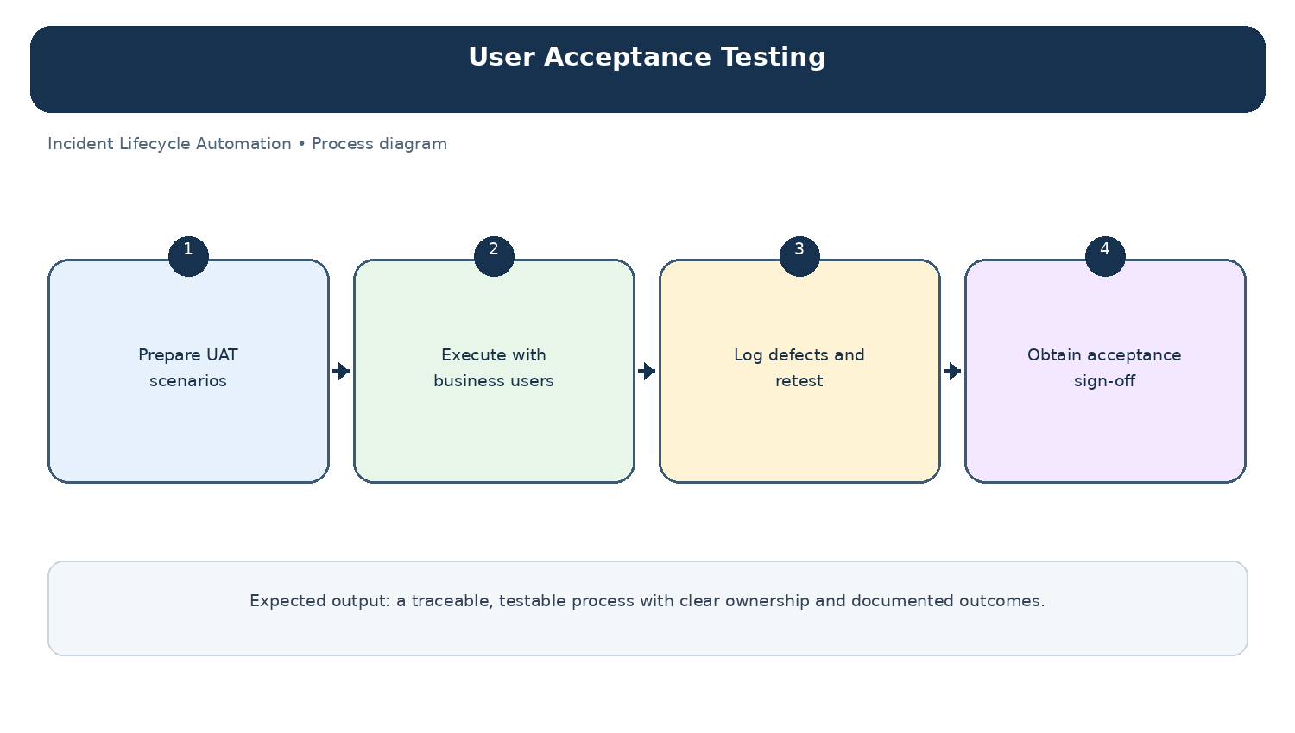
Diagram: User Acceptance Testing — project-specific process overview.

